Exploring our Community  Social Night 2023-2024  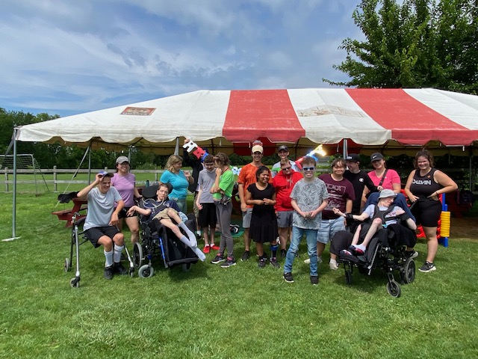  Red Roof Retreat  Community Center at Cornerstone Church  434 Hunter Rd. Niagara-on-the-Lake  - We are limited to 12 clients per evening.  - We provide 1:3 staff support. If your teen requires 1:1 support, they are welcome to attend with a private worker at a reduced fee.  - Pre-registration and payment are required by 4pm on the Tuesday before your requested program date. Refunds will only be issued if given 24 hours’ notice.  - Please bring your own dinner. | Ages 15-21 years  Thursday evenings  5pm – 8pm  Cost  $ 45.00 per evening  Dates 2023– 2024  October 12 & 26  November 9 & 23  December 7 & 21  January 11 & 25  February 8 & 22  March 7 & 28  April 11 & 25  May 9 & 23  June 6 & 20  Registration  www.redroofretreat.com  - Fill out the registration form via our website. Proof of vaccination must be uploaded.  - Email a photo of the person attending Shauna: recreation@redroofretreat.com.  - Wait for confirmation and payment information from Shauna.  